GIBSON HOUSE MANOR MUSEUM PRESENTS
SUMMER CAMP FOR ELEMENTARY SCHOOL STUDENTS AT THE MANOR
A summer camp full of history, science, nature and art!
JULY 20 – 24 ● 10am – 2pm Monday to Friday
The Gibson House Manor Museum invites all kids entering 3rd to 7th grade to join the summer camp!
$135/Week
CAMP INCLUDES:
- Touring the Gibson Manor and discovering its connection to the Underground Railroad
- Learning about the importance of astronomy and reading the stars
- Understanding Mark Twain’s “Adventures of Huckleberry Finn”
- Creating your own rafts and completing scavenger hunts around the estate
- Spend a day living Amish with no electricity and crafting your own ice houses!
- LUNCH INCLUDED
PLEASE CONTACT US AT THE MANOR TO RESERVE YOUR SPOT!
Gibson House Manor Museum and Historic Events Center
210 Liberty Street, Jamestown, PA 16134
724.456.4983 or gibsonhousemanor.org
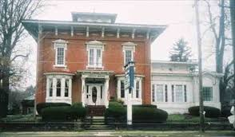

Gibson House Manor Museum Elementary School Camp Application

Student Full Name:
Date of Birth:
Address:
City: State: Zip:
Email: Cell:
Disclosure of any medical issues that need to be addressed while you are away at this Scholars Camp:
( ) check here if you would like to submit a request for ( ) 25% ( ) 35% ( ) 50% off my monthly fee through your scholarship program. Scholarship dollars are limited. Please apply early if you need funds.
Send completed Application and fee to:
Attn: Mark Boot
Friends of the Manor Charitable Trust
210 Liberty Street
Jamestown, PA 16134
724.456.4983 (questions)

